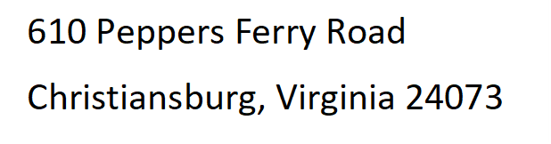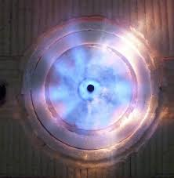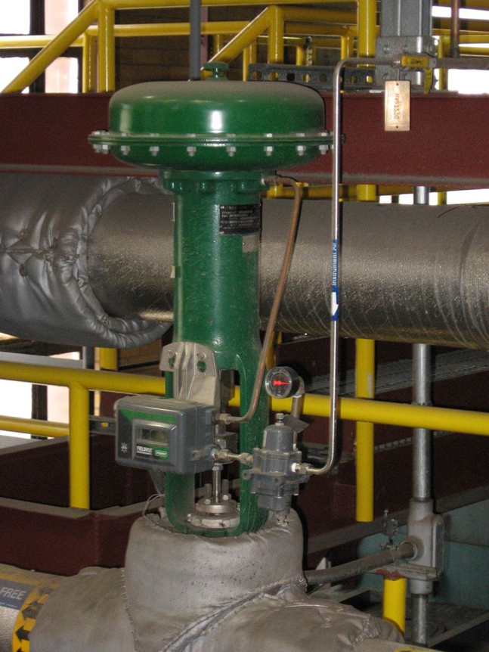

Light breakfast, beverages, and lunch will be provided each daily.

***Presented By: Thermal System Training, LLC***

***Course Dates: September 8 – 12, 2025 / 8:00 AM – 4:00 PM***

***Cost $ 2,350 per person***

***Class Location is in Christiansburg Virginia at:***

***610 Peppers Ferry Road, Christiansburg Virginia 24073***

***Reservations: 855-530-1049***

***For more information and to register visit us at:***

***Thermalsystemtraining.com***

Nearby Lodging includes:

Holiday Inn, Christiansburg 540-381-8100

Hampton Inn, Christiansburg 540-381-5874

SureStay Hotel, Christiansburg 540-381-0500

***For more information and to register visit us at:***

***Thermalsystemtraining.com***

**Topics covered includes:**

* Stationary engineering principles
* Boilers
* Steam and water fitting and accessories
* Boiler operation & maintenance
* Steam turbines
* Steam turbine operations & maintenance
* Water treatment
* Electrical principles
* Steam management
* Computer-integrated control systems

*www.thermalsystemtraining.com*

**Advanced Boiler Operator Training & Certification**

**T**

**S**

**T**

**Thermal**

**System Training LLC**