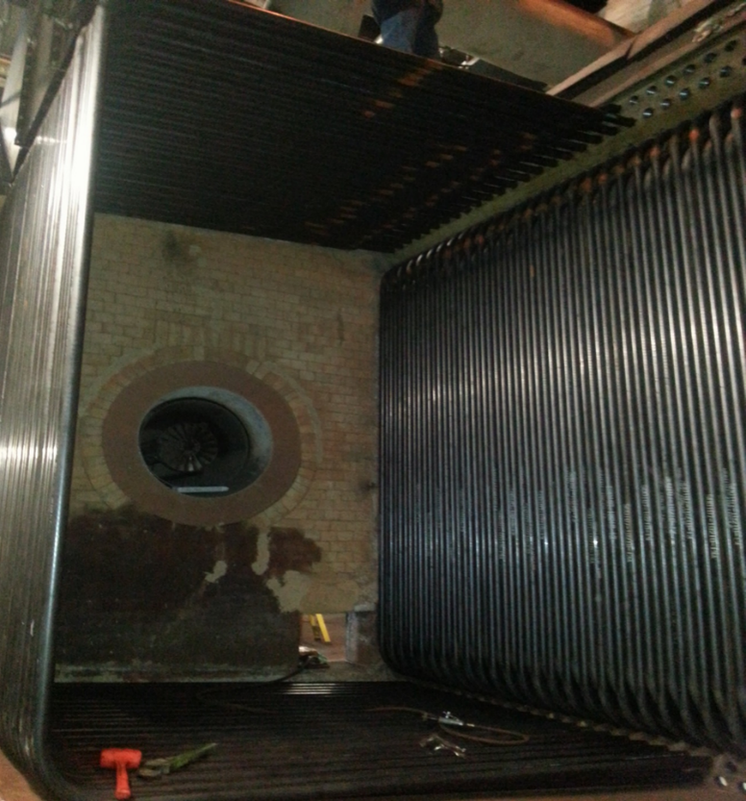

Light breakfast, beverages, and lunch will be provided daily.

Nearby Lodging includes:

Holiday Inn, Christiansburg 540-381-8100

Hampton Inn, Christiansburg 540-381-5874

SureStay Hotel, Christiansburg 540-381-0500

***For more information and to register visit us at:***

***Thermalsystemtraining.com***

***Presented By: Thermal System Training, LLC***

***Course Dates: June 23 – 27, 2025 / 8:00 AM – 4:00 PM***

***Cost $ 2,250 per person***

***Class Location is in Christiansburg Virginia at:***

***610 Peppers Ferry Road, Christiansburg Virginia 24073***

***Reservations: 855-530-1049***

***For more information and to register visit us at:***

***Thermalsystemtraining.com***

Topics covered includes:

* Steam boilers
* Boiler systems
* Steam boiler fittings
* Steam systems
* Feedwater systems
* Feedwater systems
* Water treatments
* Combustion equipment
* Fuels and combustion
* Combustion and boiler controls
* Draft systems
* Instrumentation and control systems
* Steam boiler operation

*www.thermalsystemtraining.com*

610 Peppers Ferry Road

Christiansburg, Virginia 24073

**Basic Boiler Operator Training & Certification**

**T**

**S**

**T**

**Thermal**

**System Training LLC**