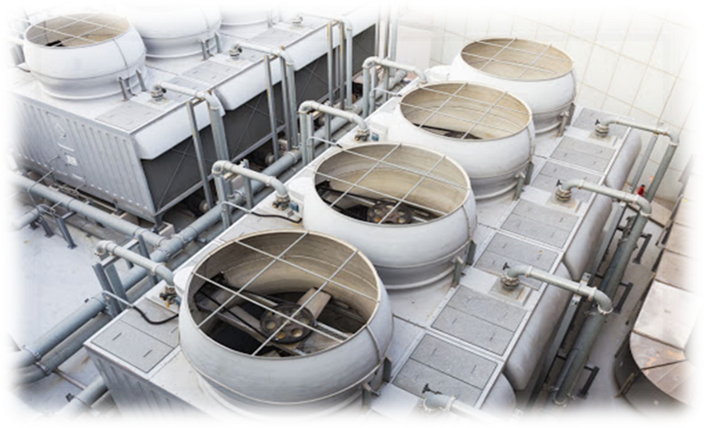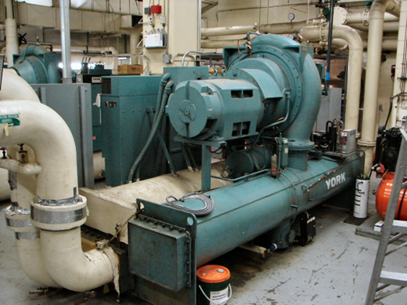

**HVAC Water Chillers & Cooling Towers Course**

***Presented By: Thermal System Training, LLC***

***Course Dates: February 10 – 14, 2025 / 8:00 AM – 4:00 PM***

***Cost $ 2,250 per person***

***Class Location is in Christiansburg Virginia at:***

***610 Peppers Ferry Road, Christiansburg Virginia 24073***

***Reservations: 855-530-1049***

***For more information and to register visit us at:***

***Thermalsystemtraining.com***

Topics covered includes:

* Refrigeration and cooling basics
* Refrigeration machines
* Chiller configurations
* Chilled water system elements
* Chilled water system control and performance
* Thermal energy storage
* Chiller operation and maintenance
* Cooling tower fundamentals
* Cooling tower components
* Cooling tower configurations and applications
* Cooling tower controls
* Condenser water treatment
* Special tower considerations
* Cooling tower operation and maintenance
* Cooling tower performance testing

Light breakfast, beverages, and lunch will be provided daily.

Nearby Lodging includes:

Holiday Inn, Christiansburg 540-381-8100

Hampton Inn, Christiansburg 540-381-5874

SureStay Hotel, Christiansburg 540-381-0500

***For more information and to register visit us at:***

***Thermalsystemtraining.com***

*www.thermalsystemtraining.com*

610 Peppers Ferry Road

Christiansburg, Virginia 24073

**T**

**S**

**T**

**Thermal**

**System Training LLC**