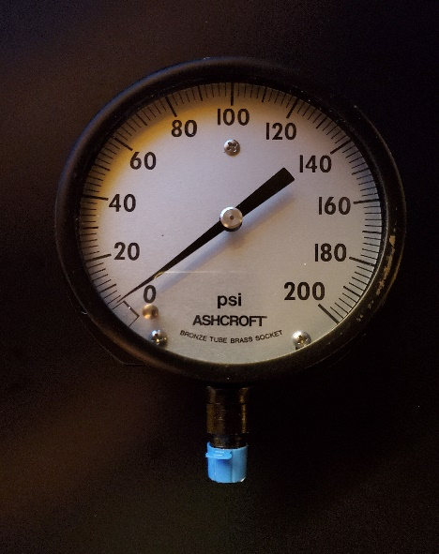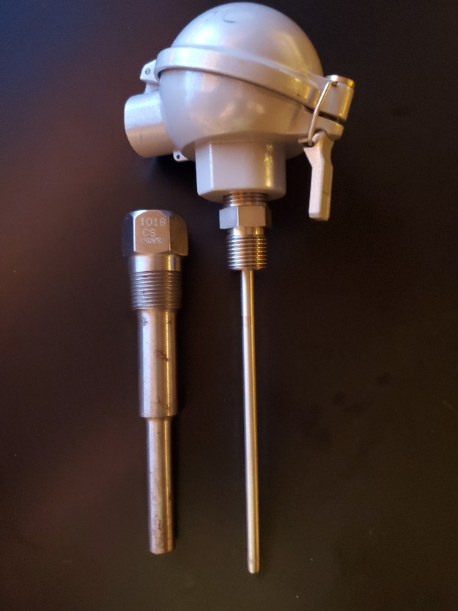

***Presented By: Thermal System Training, LLC***

***Course Dates: March 10 – 14, 2025 / 8:00 AM – 4:00 PM***

***Cost $ 2,450 per person***

***Class Location is in Christiansburg Virginia at:***

***610 Peppers Ferry Road, Christiansburg Virginia 24073***

***Reservations: 855-530-1049***

***For more information and to register visit us at:***

***Thermalsystemtraining.com***

Focus on Pressure and Temperature Instruments. Topics covered includes:

* Modern process control systems
* Control loops and strategies
* P & ID diagrams
* Temperature scales and measurement devices
* Heat transfer and units
* Specific heat and capacity
* Thermal expansion
* Thermocouples and RTD’s
* Thermistors and IR sensors
* Temperature time constants
* Pressure, head, and hydrostatic principles
* Pressure scales and units
* Manometers
* Types of pressure sensors
* Pressure transducers
* Pressure sensor calibration

**Instrumentation and Process Control One Course**

Light breakfast, beverages, and lunch will be provided daily.

Nearby Lodging includes:

Holiday Inn, Christiansburg 540-381-8100

Hampton Inn, Christiansburg 540-381-5874

SureStay Hotel, Christiansburg 540-381-0500

***For more information and to register visit us at:***

***Thermalsystemtraining.com***

*www.thermalsystemtraining.com*

610 Peppers Ferry Road

Christiansburg, Virginia 24073

**T**

**S**

**T**

**Thermal**

**System Training LLC**