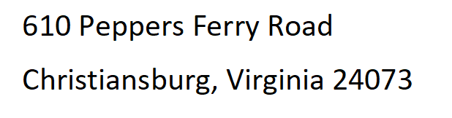

Light breakfast, beverages, and lunch will be provided daily.

***For more information and to register visit us at:***

***Thermalsystemtraining.com***

Nearby Lodging Includes:

Holiday Inn, Christiansburg 540-381-8100

Hampton Inn, Christiansburg 540-381-5874

SureStay Hotel, Christiansburg 540-381-0500

***Presented By: Thermal System Training, LLC***

***Course Dates: August 11 – 15, 2025 / 8:00 AM – 4:00 PM***

***Cost $ 2,295 per person***

***Class Location is in Christiansburg Virginia at:***

***610 Peppers Ferry Road, Christiansburg Virginia 24073***

***Reservations: 855-530-1049***

***For more information and to register visit us at:***

***Thermalsystemtraining.com***

**Topics covered includes:**

* Boiler theory and principles
* Boiler construction and design
* Steam systems and controls
* Water supply systems and controls
* Water treatment systems and controls
* Fuel systems and controls
* Draft and flue gas systems and controls
* Instrumentation and control systems

*www.thermalsystemtraining.com*

**Intermediate Boiler Operator Training & Certification**

**T**

**S**

**T**

**Thermal**

**System Training LLC**